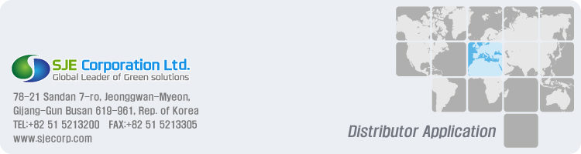
- Thank you for expressing an interest in becoming an Optima Steamer™ Authorized Distributor. Please complete the form below and return to business development department via email : sales@sjecorp.com

Your contact information
Frist Name |  | Last Name
Company Name
Street Address
City |  | Postal Code
Phone Number |  |  | Mobile
Email Address
Web Site

Select a Country

* Describe a "Desired Country" where you would like to apply for a distributorship

Current Distributorship(s)

* What products/services do you currently sell or provide? (Please be specific with brands)

Where did you learn about us?
Google Yahoo Bing Amazon Youtube Facebook Reddit
Alibaba Baidu Twitter Instagram Linkedin Vine
Pinterest Trade show Friends Business associates TV Ads.
Magazines Current distributors Direct mail
Others

Business Information
01. What was your sales revenue last year(USD)?
02. Has Applicant ever distributed or sold domestic, commercial or industrial steam cleaners?
03. Has Applicant ever seen our products in person?
04. If yes, where?
05. Does Applicant have a service center and service support team?

06. Does Applicant have a showroom and a warehouse?
07. Has Applicant ever imported goods of foreign origin to your country?
08. If yes, please describe where and be specific with brands and average annual sales.

Marketing and Sales Plan
01. Why do you want to become an Optima Steamer ™ distributor?
02. What are your aimed markets and industries?
03. Briefly describe your marketing and sales strategies in the targeted market areas
04. Briefly describe your strengths that enable you to become a successful distributor

05. What are your estimated annual target quantities in the first 3 years?
You certify that all of the information contained in this application and any attachments are given for the purpose of obtaining credit, are true and correct to the best of your information, knowledge and belief, until you give written notice of a change.

Data
Print Name of Above
Qualification (title)

